**Magnetism**

Magnetic field lines are closed in contrast to field lines of the electric field. Therefore, the magnetic field is called an eddy field (Wirbelfeld), and the electric field is called a source field (Quellenfeld).

In general, there are two relevant quantities in this topic. The magnetic flux density B (magnetische Flussdichte B) with the unit ______________, and the magnetic field strength H (magnetische Feldstärke H) with the unit ___________. We will consider these two quantities as synonyms in the context of this course, since they are related via

H=µ*B

so they are convertible into each other. µ here denotes the magnetic field constant with a value of ____________________

Thus the magnetic field strength in vacuum can be calculated.

In the next figure the closed field lines are shown. These always go from the _____________ to the ____________ pole.

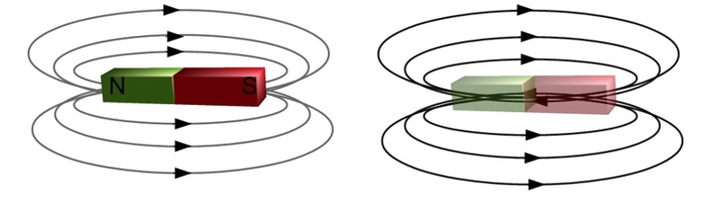

Elements, which can function as magnets themselves, are called ferromagnets. (Fe, Ni and Co)

**Current carrying conductor (Stromdurchflossener Leiter)**

Moving charges create a magnetic field around them which is normal to the direction of ______________.

The direction of this magnetic field can be found out with the ___________________.

This can be shown in the experiment of _______________.

The magnetic field of the conductor decreases the greater the **Abstand** to the wire is. In general, this relationship can be described as follows.

Calculate the magnetic field strength and flux density of a current-carrying conductor when it carries a current of 2 A. These quantities are measured at a distance of 1m.

**Current carrying coil (Stromdurchflossene Spule)**

When charges move through a coil, they create a magnetic field which is ____________________ inside the coil (magnetic flux density B is the same in every point inside the coil).

The magnetic field strength of a coil can be calculated as follows. Of course it depends on the current I, the number of turns N and the length L of the coil.

Calculate the magnetic field strength and flux density within a current carrying coil, if the coil has 100 turns, carries 2 A current and is 2 m long.

**Electromagnet**

Coils can therefore be used to generate easily calculable magnetic fields. But these fields can be intensified considerably if _______________ is placed in the middle of the field. In this case one speaks of an ___________________.

**Force in a magnetic field - Lorentz force (Lorentzkraft)**

**Lorentz force on charge in magnetic field**

If a charged particle with the charge Q moves with the velocity v through a magnetic field with the magnetic flux density B normal to the field lines, a ______________ acts on the particle. This force is the so-called Lorentz force.

Calculate the amount of charge necessary to generate a force of 20 N at a magnetic field of 1 T and a charge velocity of 10 m/s.

**Lorentz force on a current-carrying conductor**

If a current-carrying conductor is in an external magnetic field, the two magnetic fields ____________ each other. ______________ acts on the conductor.

Calculate the force F which a 0.1 m long conductor swing experiences when a current of 10 A flows through it and the swing is in a 1 T strong magnetic field.

